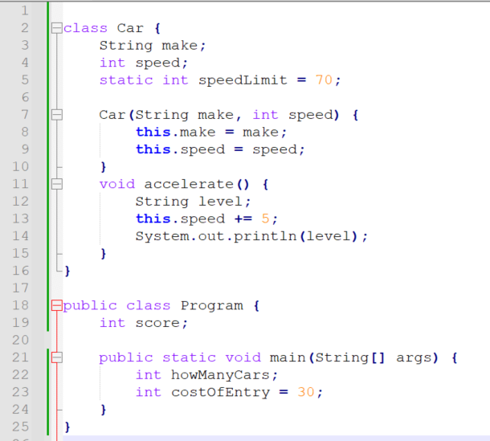

1. Name all of the local variables and state their initial values.
2. Name all of the instance variables and state their initial values.
3. What access modifier would you usually use for instance variables? (public, protected, <default> or private) Why? And why does <default> appear between angle brackets in this question?
4. Name the parameter variables and state which line(s) they appear on.
5. What is the exact name of the file that the above code is stored in? (We cannot see the name at the top but we can work it out.)
6. How many constructors are there in the Car class?
7. How many constructors are there in the Program class?
8. Which line of code marks the program’s entry?
9. What changes are necessary in order to compile and run the code?
10. Assuming any necessary changes are made, what would be a suitable line of code to create an instance of Car, and where would you place it?